1. Write a Java Program to find GCD of two given numbers.

2. Write a java program to LCM of TWO given number.

3. Write a Java Program to print all the Prime Factorsof the Given Number.

4. Check whether the Given Numberis a Palindrome or NOT.

5. Write a Java Program to check whether the Given Number is Prime Number or NOT.

*Solution* :

**import java.util.*;**

**public class PrimeNumber {**

**public static boolean primeNumberChecker(int n){**

**for(int i = 2 ;i<n ; i++){**

**if(n%i == 0){**

**return false;**

**}**

**}**

**return true;**

**}**

**public static void main(String[] args) {**

**Scanner sc = new Scanner(System.in);**

**System.out.print("Enter First Number = ");**

**int a = sc.nextInt();**

**if(primeNumberChecker(a)){**

**System.out.println("Prime Number");**

**}**

**else{**

**System.out.println(" Not a Prime Number");**

**}**

**}**

**}**

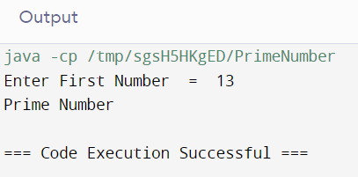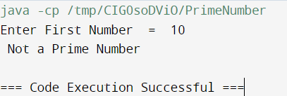

6. Write a Java Program to check whether the given number is Armstrong Number or NOT.

*Solution* :

**import java.util.*;**

**public class ArmstrongNumber {**

**public static int sumOfDigitCube(int n){**

**int sum = 0;**

**while(n!=0){**

**int digit = n%10;**

**n = n/10;**

**sum += Math.pow(digit , 3);**

**}**

**return sum;**

**}**

**public static void main(String[] args) {**

**Scanner sc = new Scanner(System.in);**

**System.out.print("Enter First Number = ");**

**int a = sc.nextInt();**

**int digitCubeSum = sumOfDigitCube(a);**

**if(a == digitCubeSum){**

**System.out.println("Armstrong Number");**

**}**

**else{**

**System.out.println(" Not a Armstrong Number");**

**}**

**}**

**}**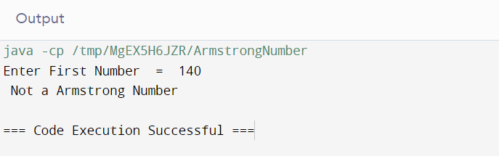

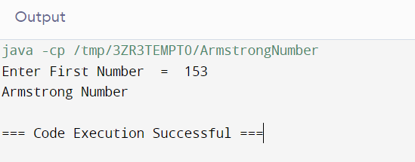

7. Write a Java Program to check whether the given number is Perfect Number or NOT.

Solution :

**import java.util.*;**

**public class perfectNumber {**

**public static int sumOfFact(int n){**

**int sum = 0;**

**for(int i=1;i<n;i++){**

**if(n%i==0 ){**

**sum += i;**

**}**

**}**

**return sum;**

**}**

**public static void main(String[] args) {**

**Scanner sc = new Scanner(System.in);**

**System.out.print("Enter First Number = ");**

**int a = sc.nextInt();**

**int sum_a = sumOfFact(a);**

**if(a == sum_a){**

**System.out.println("Perfect numbers");**

**}**

**else{**

**System.out.println("Not a Perfect Number ");**

**}**

**}**

**}**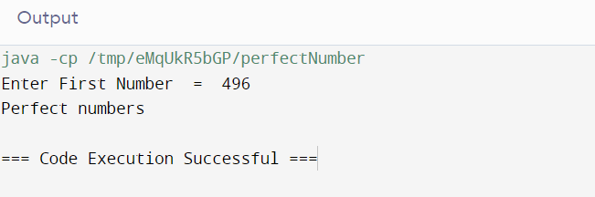

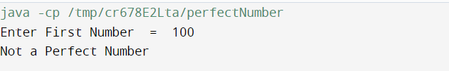

8. Write a Java Program to check whether the given numbers are Amicable Numbers or NOT.

Solution :

**import java.util.*;**

**public class perfectNumber {**

**public static int sumOfFact(int n){**

**int sum = 0;**

**for(int i=1;i<n;i++){**

**if(n%i==0 ){**

**sum += i;**

**}**

**}**

**return sum;**

**}**

**public static void main(String[] args) {**

**Scanner sc = new Scanner(System.in);**

**System.out.print("Enter First Number = ");**

**int a = sc.nextInt();**

**System.out.print("Enter Second Number = ");**

**int b =sc.nextInt();**

**int sum_a = sumOfFact(a);**

**int sum_b = sumOfFact(b);**

**if(a == sum_b && b == sum_a){**

**System.out.println("Amicable numbers");**

**}**

**else{**

**System.out.println("Numbers are not Amicable ");**

**}**

**}**

**}**



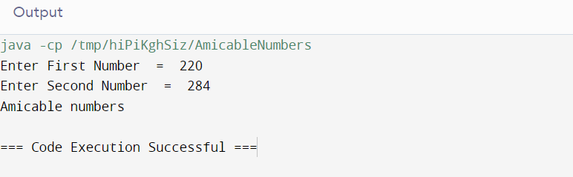

9. Write a Java Program to check whether the given number is Ramanujam's Number or NOT.

Solution :

10. Write a Java Program check whether the given number is Automorphic Number or NOT.

Solution :